Evolution Induced By Invasive Species Alters Arthropod Community Composition and Network Structure

David Solance Smith, Matthew K. Lau, Ryan Jacobs, Jenna A. Monroy, Stephen M. Shuster and Thomas G. Whitham

Abstract
Invasive species are thought to be one of the biggest threats to native ecosystems; however, no study has used a genetics perspective to examine how invasive species alter community dynamics. We study how introduced elk are causing microevolution of the native plant, Solidago velutina, which further changes the composition and network structure of the plant-associated arthropod community. We used a common garden to show two patterns. First, plants from sites with elk evolved to flower three weeks before plants originating from sites without elk. Second, plants originating from sites with elk supported fewer total arthropods, a different composition of arthropod species and different arthropod interaction networks compared to plants originating from sites without elk. These results show that evolution caused by anthropogenic forces can have a substantial ripple effect on the surrounding community. Further, studies that neglect to consider changes to genetic variation may fail to accurately predict how invasive species alter native communities.

Key words: community genetics, exotic species, genes to ecosystems, introduced species, plant-insect interaction, ungulates

Introduction
Invasive species are thought to be one of the biggest threats to native communities (Wilcove et al 1998, Sala et al 2000, Vavra et al 2007), causing both species extirpations (Coblentz 1978, Mooney and Cleland 2001) and disruptions to community composition and species interactions (Christian 2001, Vazquez 2002, Sanders et al 2003). For example, Christian (2001) showed that the invasive Argentine ant (Linepithema humile) displaces native ant species, which further alters seed dispersal and plant species recruitment. Because native ant species are known to bury seeds, which protects them from herbivory and fire and ultimately facilitates successful germination, displacement of native ant species by the invasive indirectly caused a shift in plant species recruitment. This study is particularly important because it shows that considering indirect effects can reveal substantial changes to native communities caused by invasive species.
In addition to disrupting community dynamics, invasive species can also cause evolution of native species (e.g. Vourc’h et al 2001, Callaway et al 2005, Strauss et al 2006). Vourc’h et al (2001) studied the invasion and evolutionary impacts of deer (Odocoileus hemionus) on the chemical defenses of red cedar (Thuja plicata.) Forests on the Haida Gwaii archipelago evolved for ~10,000 years in the absence of deer before their introduction around 1900. Vourc’h et al (2001) showed that large island trees (i.e. trees that were established before the introduction of deer) and their seedlings had lower levels of chemical defenses compared to mainland trees, which evolved with deer and island trees that were established after the introduction of deer, suggesting that defensive chemical profiles have evolved since the recent introduction of these mammalian herbivores (Vourc’h et al 2001). While invasive species are known to cause both evolution of native species and disruption to community dynamics, we know of no study that links these two phenomena to show the series of direct and indirect effects by which invasive species causes evolution of a native species, which further alters the surrounding community.
A community genetics perspective (e.g. Rowntree et al 2011, Whitham et al 2012) that examines the role of genetic diversity in shaping communities may reveal how evolution of one species could have substantial cascading effects on the local community (Johnson et al 2009, Smith et al in review). Several studies have demonstrated that genetic variation in one species can influence community composition (Johnson and Agrawal 2005, Shuster et al 2006), community stability (Keith et al 2010) and species interactions (Bailey et al 2006, Johnson 2008, Mooney and Agrawal 2008, Smith et al 2011). Mechanistically, the genetic variation of one species influences a species’ traits, which then influence the surrounding community. Knowing that genetically-based traits sufficiently influence the surrounding community, it is possible that evolution of these traits will result in a change to the local community (Harmon et al 2009, Johnson et al 2009, Palkovacs and Post 2009, Bassar et al 2010, Smith et al in review).
We investigated how invasive rocky mountain elk (Cervus canadensis nelsoni), which were introduced to Northern Arizona ~80ya (Truett 1996), may be causing native goldenrod (Solidago velutina) to evolve and how this evolution alters the plant-associated arthropod community. Three previous findings led us to our hypotheses. Introduced ungulates are known to cause rapid evolution of plants (Vourc’h et al 2001). In addition, elk are known to forage on Solidago (Kufeld 1973), potentially causing plant populations to evolve. Finally, genetic variation in Solidago is known to influence the surrounding arthropod community (e.g. Maddox and Root 1987, Crutsinger 2006, Genung et al 2010). Thus, elk-induced evolution of Solidago could further change arthropod community dynamics. We use a common garden experiment to show two patterns: 1) S. velutina has evolved in the presence of exotic elk 2) the evolution of S. velutina alters the composition of the arthropod community on S. velutina. Our results are important as they show that the community-level impacts of introduced species may be difficult to understand and impossible to predict without considering the interaction of ecological and evolutionary dynamics.

Methods
Seed Collection and Common Garden
We collected seed from 73 individual S. velutina plants across six sites; three sites with relatively high elk densities and three sites with no measurable elk usage (Smith et al in review). Seeds were placed in paper envelopes and stored at room temperature until the following February. Seeds from each mother were placed in plastic petric dishes in between two pieces of wetted filter paper (Whatman No. 1). Petri dishes were checked daily and watered as needed. Seeds took between one and three weeks to germinate. After three weeks, seedlings were transferred to potting soil in bookplanters (Tinus Roottrainers, Spencer-Lemaire, Edmonton, Alberta Canada). Bookplanters were rearranged every two weeks to minimize microsite effects in the greenhouse
At the beginning of the second growing season plants were transplanted into 2L pots, which were filled with potting soil. In late spring, we transferred the plants to Hart Prairie Preserve (Nature Conservancy) north of Flagstaff, AZ USA, where they were placed inside an elk exclosure fence, within a natural population of S. velutina. Pots were arranged in a randomized design and watered as needed. In the late summer, when the plants began to flower, we measured the following traits on all flowering plants: i) Inflorescence size was measured as the number of florets per inflorescence. Some plants produced multiple inflorescences, in which case we used the average number of florets per inflorescence size in our analyses below. ii) For flowering phenology, we monitored plants two to three times per week and scored a plant as flowering when one half of the florets were completely open. We chose to score half the florets because not all florets will open (personal observation). Flowering phenology was treated as a continuous variable where June 1st was day one and flowering time was recorded as the day number since June 1st. iii) Plant height was measured from ground level to the top of the inflorescence. We also performed three arthropod surveys on each plant. Two days after the plant was considered flowering, we performed the first of the three surveys. Subsequent surveys were performed every other day until surveys were completed. For each survey, we visually watched plants for five minutes and recorded all arthropods visiting the plant.
We conducted our experiment during the second growing season; therefore, it is unlikely that maternal effects confounded our results. Weis et al (1987) found that maternal effects in Solidago greatly decreased with time in a common environment. In their experiment, only two of the 17 traits (number and length of rhizomes) showed significant maternal effects, after the first growing season. Further, those maternal effects explained less than 10% of variation in plant traits. Of those traits that were measured, none showed significant maternal effects after the second growing season (Weis et al 1987). Because we conducted our experiment towards the end of the second growing season, we have reason to believe maternal effects were minimized, if not completely eliminated.

Elk Removal Experiment
In addition to the common garden experiment, we used two elk exclosures to examine plant traits in the presence and absence of elk. To measure relative flowering time (i.e. phenology) inside and outside the exclousres, we surveyed 183 sexual plants (i.e. plant with flowering stalks and developing buds) inside and outside of the two exclosures (Exclosue1 n_{in} = 60, no_{out}=60, Exlosure2 n_{in} = 50, n_{out} = 13). These data tested the hypothesis that a higher proportion of plants would have flowered by a fixed date (i.e. plants would flower relatively early) outside the exclosure, in the presence of elk. We scored each individual as flowered (when 50% of the buds had opened) or not yet flowered. We surveyed other plant traits inside and outside the exclosures and report those results in another manuscript (Smith et al. in review)

Statistical Analysis
In the common garden, we modeled most univariate traits (flowering phenology, number of florets, arthropod richness and arthropod abundance) with a generalized linear mixed model, with a (quasi-) Poisson distribution and log link function. Because of its normal distribution, we used a linear mixed model to analyze plant height. In both models, seedling family was nested within site, which was nested within the elk/no-elk gradient. Family was treated as a random variable, while site and the presence/absence of elk were treated as a fixed factor. Lastly, because the focus of this paper was to examine the evolution of plant traits in the presence of elk, we only report the differences between plants from elk and no-elk sites (see below).
We used three methods to examine differences in the arthropod community between the elk and no-elk sites. To graph and visually examine arthropod community structure, we used non-metric multidimensional scaling (NMDS) (McCune & Grace 2002). Before analyses, we removed species that appeared only once in the data set because a single occurrence of a species does not provide reliable information of group affinity. Additionally, we relativized abundances of each species by its maximum abundance to decrease the influence of extremely abundant species (McCune & Grace 2002). We then used a nested PerMANOVA (Anderson 2001) with Bray-Curtis distances to test for compositional differences in the arthropod communities. Like the model for plant traits, plant family was nested within site, which was nested within the elk / no-elk gradient.
To exam co-occurrence patterns among the flower-associated arthropod species, we used Generalized Additive Models (GAM; Hastie and Tibshirani 1990) to model two networks: one for plants originating from sites with elk and another from sites without elk. To allow for the inclusion of species abundances, each network was constructed by assessing model fit of three possible GAM’s (gam package in R version 15.1.0 (Hastie 2011; R Development Core Team 2012) for each pairwise combination of species: 1) a “null” model with no slope, 2) a linear model and 3) a quadratic or hump-shaped model. The GAM with the largest Akaike weight was selected as the best fitting model (Burnham and Anderson 2002). If the “null” model was selected then the connection for that species pair was set to zero (i.e. there was no connection between that pair of species). The resulting network models were then analyzed for differences in the global structure of co-occurrence patterns. For weighted network statistics and plotting, we used the linear coefficient of each GAM, regardless of whether the preferred model was linear or quadratic, to weight connections among species.

Analysis of Exclosures
To test the hypothesis that a higher proportion of sexual plants flowered on a fixed date (i.e. they flowered relatively early) in the presence of elk, we used a three-way Chi square contingency table. This test was chosen because we sampled two exclosures (which varied in space), on different days.

Results
Plant Traits
We found evidence that some traits of S. velutina have evolved in the presence of elk.
Plant height (F_{1,105} , p = 0.0616) or inflorescence size (F_{1,105} , p = ) did not differ in the presence of elk. However, we found evidence that flowering phenology has evolved in the presence of elk. Plants originating from sites with elk flowered nearly three weeks earlier than plants originating from no-elk sites (Fig 1a). Using June 1st as day 0, plants from no-elk sites flowered, on day 90 (August 30), whereas plants from elk sites flowered on day 71 (August 10; F_{1,105} = 11.69, p < 0.0001; Fig 1a). Consistent with these results, plants growing outside of the exclosures (i.e. in the presence of elk) had a fewer number of plants already flowering by a given date. At one exclosure, on DATE 45% of plants had flowered in the absence of elk, while 65% had flowered in the presence of elk (p = 0.0215). We found a similar pattern at the other exclosure where only 8% of plants had flowered in the absence of elk, but 54% had flowered in the presence of elk. Based on the common garden results, we did not find evidence that inflorescence size had evolved in the presence of ungulates. (average number of florets with elk = 42.4, without elk = 48.5; F = 0.0661, p=0.7998; Fig 1b), which contradicts what we found in the elk removal experiment (Smith et al in review).

Community Response
Even though richness did not differ, we found differences in total arthropod abundance, arthropod community composition and arthropod network structure on plants that originated from the presence and absence of elk. The two groups of plants did not differ with respect to species richness (average richness with elk = 2.7, without elk = 2.7, X² = 0.0974, p = 0.7550 ), however, arthropods were ~35% less abundant on plants originating from sites with elk (average abundance with elk = 20.7, without elk = 31.7, d.f. = 1, X² = 61.62, p < 0.0001). Community composition did differ across the elk / no-elk gradient (F_{1,90} = 3.29, p = .0065, Fig. 2).

Network structure of the arthropod community differed between (Fig 3). While the total number of connections in the communities was not different (elk = 38, no elk = 35)… there were differences in centralization and changes to particular pairwise connections in the network. NETWORK RESULTS…

Discussion
Plant Traits
Our results show that invasive species can have dramatic direct and indirect effects on a community by first causing evolution of native plants, which then alters the species composition and network structure of the plant-associated community. Plants originating from sites with elk flowered almost three weeks earlier than plants originating from elk-free sites (Fig 1a). Because these results were from a common garden, it shows that there has been a genetic-based shift (i.e. evolution) of flowering phenology in the presence of invasive elk. Corroborating these results we used an elk removal experiment to show that S. velutina tended to flower earlier in the presence of elk. At both exclosures, we found fewer plants had flowered by a certain date, suggesting that S. velutina flowers relatively early in the presence of elk. Because this experiment manipulated the presence and absence of elk, while presumably leaving all other environmental variables constant, it supports the idea that elk are the causative agent explaining the evolution of flowering phenology. Solidago velutina may be flowering early to avoid herbivory (Pilson 2000). Elk in mountainous areas of Arizona are known to seasonally migrate along an elevational gradient, spending early summer at higher elevations (between 2400 and 2800m) and moving to lower elevations in the fall (Wallace and Krausman 1997). This study was conducted at a relatively low elevation (~2100m), thus, it is possible that if plants flower before elk arrive in the fall, they may be able to sexually reproduce before being eaten.
Although it contradicts previous findings (Smith et al in review) we did not find a difference in the inflorescence sizes of plants from elk and elk-free sites (Fig 1b). Inflorescence size across a natural range in elk abundances and using the same elk exclosures as this experiment, Smith et al (in review) found that S. velutina in the presence of elk had inflorescences about half the size compared to plants in the absence of elk. This was surprising given that previous research showed that inflorescence size was negatively related to elk abundance, such that areas with high elk densities had smaller inflorescences (Smith et al in review). It is unknown why previous data showed smaller inflorescences in sites with elk, but the common garden, which quantified how the role of evolution, did not show this pattern. Perhaps gene flow between elk and no-elk sites or correlation with other traits under selection (Weis 1996) prevented evolution of inflorescence size.

Arthropod Community
Arthropod community composition and network structure differed on plants that originiated from elk and elk-free sites.

NETWORKS

2) NETWORK STRUCTURE] – GIVE SPECIFICS ABOUT THE PRESENCE/ABSENCE OF SPECIES AS WELL AS SPECIFICS ABOUT THE INTERACTIONS

In comparing the two groups of plants, some metrics show that the network structure of the arthropod community has changed in the presence of exotic elk. While the total number of connections in the network (i.e. the number of significant pairwise covariances) was similar between the two groups of plants (elk = 38, no elk = 35), … what about fragmentation? (elk = 0.29, no elk = 0.35)

We also found that arthropod communities on no-elk plants were ~2.5x more centralized compared to the arthropod communities on elk plants (elk = .049, no elk = 0.099) Fig Centralization).

The two groups of plants also supported different pairwise interactions. For example, on plants from sites without elk, arthropod13 (Gray Moth) interacted with 7 other species and arthropod16 (humpback fly) did not interact with other arthropods. Conversely, on plants from sites with elk, artrhropod13 did not interact with any other arthropod, while arthropod 13 interacted with three other arthropods (Fig 3).

…Because this experiment was conducted in a common garden, it suggests that in the presence of elk, the genetics of S. velutina have changed in such a way that alters the composition and network structure of arthropods on the plant.

Novelty of Network Approach in a Genetics Context
While several studies have used network approaches to study altered community dynamics (e.g. Vazquez and Simberloff 2003) this is the first paper, to our knowledge to use a network approach to examine community networks on different evolutionary lineages of another species. Specifically, this study examined arthropod community networks on two evolutionary lineages of S. velutina and showed that species interactions can differ across plants with different evolutionary histories and phenotypes. Other studies have shown that species interactions can be contingent upon the presence or absence of other species (Strauss YEAR). Here, we show that a phenotypic change to one species (and not necessarily its addition or removal) can alter species interactions between other species.

CONCLUSIONS
MECHANISM –
The data reported is the first to provide insight into a genetic mechanism by which invasive species alter natural communities. Previous studies have shown a variety of mechanisms by which invasive species directly or indirectly alter communities (Vazquez 2002). Invasive species can directly displace native species, via consumption or competition (Huntly 1991 – from Vazquez review), which alters community composition. Invasive species can also indirectly alter communities (Wardle 2001, Christian 2001, Koh et al 2004). For example, when one species is obligately dependent on another, the displacement of one species can cause the other to be displaced (Koh et al 2004). In another example CHRISTIANSEN While these studies showed some ways by which invasive species alter native communities we know of no study that used a genetic perspective to show how invasive species alter communities. Here, we showed that altering the genetic-based traits of a single species cascaded to alter local species composition and network structure. These results highlight the importance of intraspecific variation and an evolutionary perspective in understanding community dynamics (Bolnick et al 2011, Hendry et al 2011, Whitham et al 2012).

Other anthropogenic forces may cause similar patterns in communities.
Anthropogenic changes to the environment, like invasive species, habitat fragmentation and climate change have already shown to cause rapid evolution. (Young et al 1996, Callaway et al 2005, Strauss et al YEAR, Franks et al 2007). For example, climate change is known to act as a strong agent of natural selection (Sthultz et al 2009), causing rapid evolution in flowering phenology (Franks et al 2007). Data reported here suggests that this rapid evolution could have substantial cascade effects on the surrounding community. – PINYON EXAMPLE? …. Which are known to support different rates of decomposition and nutrient cyclilng (CITATIONS), different soil microbial communities (CITATIONS) vertebrate seed dispersers (CITATION). Thus, the effects of climate change on the frequency distribution of plant phenotypes could indirectly change the surrounding community.
While the studies mentioned above have examined the influence of evolved variation on community composition (i.e. the richness and relative abundances species), they have largely ignored the network structure, which describes patterns of the species co-occurrences and possible species interactions within the community (CITATIONS). Network structure helps to describe much of a community’s dynamics. For example, network structure has shown to influence community stability (Solé and Montoya 2001) energy flow (Tylianakis et al 2007), species coexistence and the maintenance of biodiversity (Bascompte et al 2006, Bastolla et al 2009). Tylianakis et al (2007) studied habitat modification via agricultural practices and its effects on herbivore-parasitoid communities. In their study, habitat modification did not change the richness or abundance of species, but it did change the patterns of species interactions and energy flow. In other words, conventional community metrics (richness and abundance) failed to discriminate among altered habitats, indicating that perturbations to the communities may be overlooked in studies that do not measure network structure (Tylianakis et al 2007).

These results have implications for restoration and conservation biology. Specifically, in restoring or protecting native habitats, it is important to consider the evolutionary history of plants….

Acknowledgements
We thank B Blake and P Patterson at the NAU research greenhouse and the Nature Conservancy, especially Neil Chapman for their assistance establishing the common garden. Special thanks to D. and L. Monroy Solance. Funding was provided by NSF FIBR grant (GRANT NUMBER) and an NSF IGERT to DSS.

Literature Cited

Bascompte J (2009) Disentangling the web of life. Science 325: 416 – 419.

Bascompte J, Jordano P, Olesen J M (2006) Asymmetric coevolutionary networks
facilitate biodiversity maintenance. Science 312: 431 – 433.

Bassar, R.D. et al (2010) Local adaptation in Trinidadian guppies alters ecosystem
processs. Proc Natl Acad Sci USA 107: 3616-3621

Bastolla U, Fortuna M, Pascual-Garcia A, Ferrera A, Luque B, Bascompte J (2009) The
architecture of mutualisitic networks minimizes competition and increases biodiversity. Nature 458: 1018 – 1021.

Bolnick

Callaway, RM, Ridenour, WM, Laboski T, Weir T, Vivanco JM (2005) Natural selection
for resistance to the allelopathic effects of invasive plants. J Ecol 93: 576-583

Collins, W.B, P.J. Urness and D.D. Austin 1978. Elk diets and activities on different lodgepole
pine habitat segments. The Journal of Wildlife Management 42:799-810.

Crutsinger GM, Collins MD, Fordyce JA, Gompert Z, Nice CC, Sanders NJ (2006) Plant
genotypic diversity predicts community structure and governs an ecosystem process. Science 313: 966-968.

Genung MA, Lessard JP, Brown CB, Bunn WA, Cregger MA, Reynolds WN, Felker-
Quinn E, Stevenson ML, Hartley AS, Crutsinger GM, Schweitzer JA, Bailey JK (2010) Non-additive effects of genotypic diversity affect pollinator visitation. PLoS ONE 5:e8711.

Harmon LJ, Matthews B, Des Roches S, et al. 2009. Evolutionary diversification in
stickleback affects ecosystem functioning. Nature 458: 1167-1170.

Hendry et al YEAR

Johnson, MTJ, Vellend M and Stinchcombe JR (2009) Evolution in plant populations
as a driver of ecological changes in arthropod communities. Phil Trans R Soc B 364: 1593 - 1605

Kufeld, R.C. 1973. Foods eaten by the rocky mountain elk. Journal of Range Management 26: 106-113.

Maddox, G D and Root R B (1987)

Mooney HA and Cleland EE (2001) The evolutionary impact of invasive species. Proc
Natl Acad Sci USA 98: 5446-5451

Palkovacs, E P and Post D M (2009) Experimental evidence that phenotypic
divergence in predators drives community divergence in prey. Ecology 90:
300-305

Pilson (2000)

Rowntree J K, Shuker D M, Preziosi R F (2011) Forward from the crossroads of
ecology and evolution. Phil Trans R Soc B 366: 1322 – 1328.

Solé R V, Montoya J M (2001) Complexity and fragility in ecological networks (2001)
Proc R Soc London B 268: 2039 - 2045

Strauss S Y, Lau J A, Carroll S P (2006) Evolutionary responses of natives to
introduced species: what do introductions tell us about natural
communities? Ecol Lett 9: 357 – 374.

Truett, J. (1996) Bison and elk in the American Southwest: in search of the pristine.
Environ Manage 20: 195-206

Tylianakis JM, Tscharntke T, Lewis O T (2007) Habitat modification alers the
structure of tropical host-parasitoid food webs. Nature 445: 202 – 205.

Vazquez, D P 2002 Multiple effects of introduced mammalian herbivores in a
temperate forest. Biological Invasions 4: 175-191.

Vazquez D P and Simberloff D (2003) Changes in interaction biodiversity induced
by an introduced ungulate. Ecol Lett 6: 1077 – 1083.

Vourc’h, G., Martin, J.-L., Duncan, P., Escarré, J., and Clausen, T.P. (2001). Defensive
adaptations of Thuja plicata to ungulate browsing: a comparative study
between mainland and island populations. Oecologia 126: 84-93

Wallace MC and Krausman PR (1997) Movements and home-ranges of elk in Eastern Arizona. Proceedings Deer/Elk Workshop – Arizona
{more up to date publication – in Journal of Wildlife Research}

Weis, A.E., Hollenbach, H.G. & Abrahamson, W.G. (1987). Genetic and maternal
effects on seedling characters of Solidago altissima (Compositae). Amer. J.
Bot., 74, 1476-1486.

Weis, AE 1996 Variable selection on Eurosta’s gall size, III: can an evolutionary
response to selection be detected? J Evolution Biol 9: 623 – 640.

Whitham T G (2012) Trends Plant Sci

Wilcove (1998) Quantifying threats to imperiled species in the United States.
Bioscience 48: 607-615.

Burnham, K. P., and Anderson, D.R. (2002). Model Selection and Multimodel Inference: A Practical Information-Theoretic Approach, 2nd ed. Springer-Verlag.
Hastie, T. (2011) gam: Generalize Additive Models. R package version 1.06.2.
Hastie, T. J. and Tibshirani, R. J. (1990). Generalized Additive Models. Chapman & Hall/CRC.
R Development Core Team. (2012) R: A Language and Environment for Statistical Computing. R Foundation for Statistical Computing. Vienna, Austria.
Solidago spp. tend to be self-incompatible (Gross and Werner 1983 – Ecological Monographs)a

Table 1.
*NOTE: This table used a nested linear mixed model, where family was a random effect and site and elk were fixed effects. Leaf number and Leaf area were data from 2009 (after one year) and the number of florets, plant height and phenology were from 2010 (after two years).

Trait | Site | Elk? | No-Elk/ Elk (values)
Number florets | F=1.2964 p=.3289 | F= .4435, p=.5189 | 42.4 (±7.5)  48.8(±5.8)
Plant Height | F=6.903, p=.0018 | F=3.9612, p=.0630 | 36.4(±1.3)  33.2(±1.0)
Flowering Phenology | F=2.594, p=.0902 | F=35.7581, p<.0001 | 91.0 (±2.6)  71.1(±2.0)
Leaf number | F=1.75, p=.1508 | F=6.36  p= .0143 | 10.9 (±1.0)  7.4 (±1.0)
Leaf Area | F=2.99  P=.0265 | F= 4.89  P=.0313 | 7.15 (±.29)  6.25 (±.28)

Fig 1.
Evolution of S. velutina in the presence of elk. There was no difference in inflorescence size (measured as the number of florets per inflorescence) in the presence of elk (A, p value?). However, we did find evidence that flowering phenology evolved. Plants originating from sites with ungulates flowered nearly three weeks early than plants originating from sites with no ungulates (B, p value?
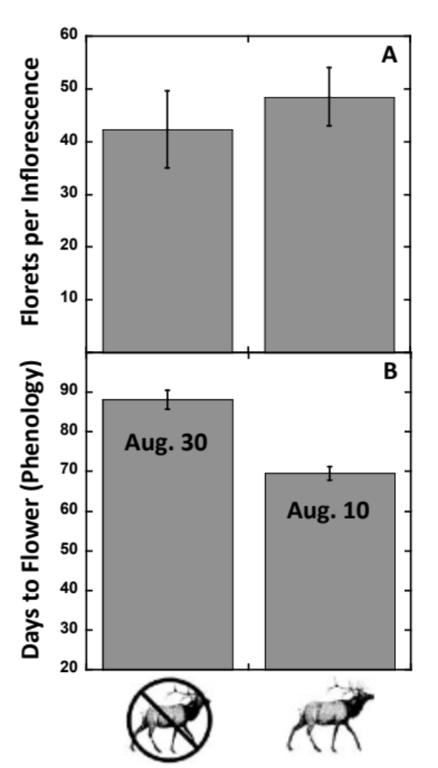

Fig 2. An NMDS plot of the arthropod communities on S. velutina that originated from sites with and without elk. Results from the perMANOVA (see Results section) show that plants originating from sites with elk (squares) supported a significantly different arthropod community than S. velutina originating from sites without elk (circles).

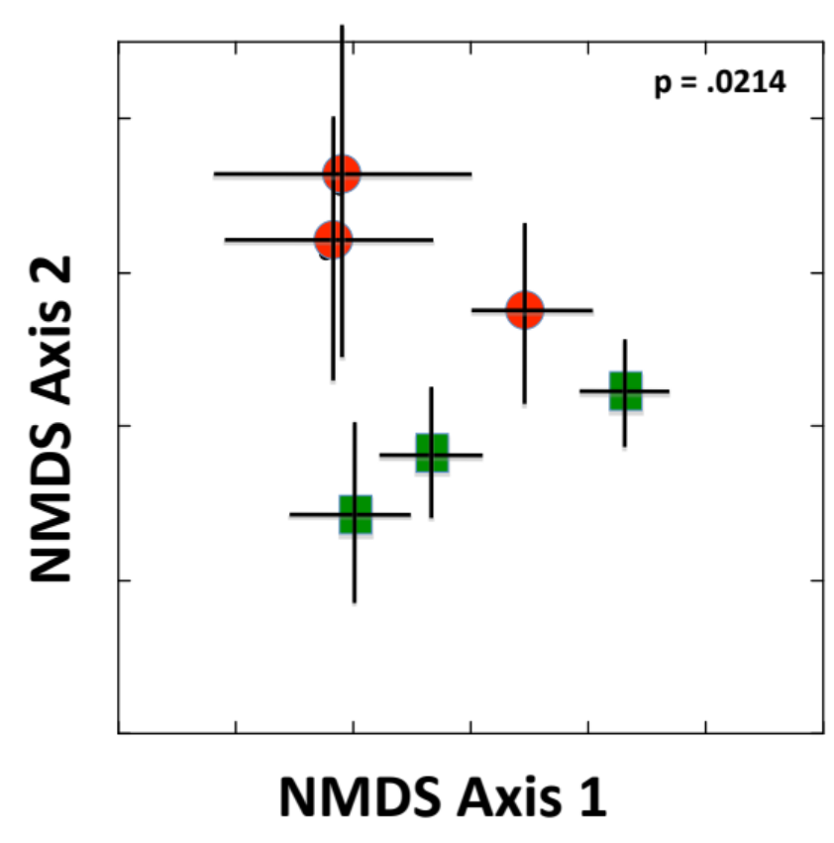

Fig 3. Network graphs of the arthropod communities on S. velutina collected from sites with and without elk.

